Production Release Engineering for a Cross-Platform Arcade Game
Gabriel Veltri, Fernando Hernandez Leon, Austin Kelemen, and Luke Hoyle
College of Engineering and Technology, Grand Canyon University
STG-455: Capstone Project I
Dwight Farris
November 1, 2026

Production Release Engineering for a Cross-Platform Arcade Game
This portfolio documents the STG-455 capstone project of Gabriel Veltri (team lead), Fernando Hernandez Leon, Austin Kelemen, and Luke Hoyle. The project began in September 2026 as production release engineering for Studio XE, a React Native and Expo mobile application owned by the industry partner Studio XE (Community HDP). The team completed onboarding and nondisclosure agreements on October 2, 2026, and contacted the partner repeatedly to obtain the source code, developer accounts, and staging environment, but the partner had not provided access by the end of October. Every critical path task in the original plan depended on that access, so on October 30, 2026, the team moved the project to an application it owns: an original two-dimensional arcade space shooter, in the tradition of Galaga (Namco, 1981), built in Unity 6 for iOS, Android, and the web.
The engineering purpose of the project has not changed. The team will take a working game from “it runs on a developer’s computer” to “a tester installs it from Apple TestFlight or Google Play,” with crash and error reporting, an automated build-and-submit pipeline that produces signed builds, automated smoke tests in continuous integration (CI), and a documented operating system (OS) and device support matrix. What changes is that the team also builds the product itself, which gives it full control of the source code, accounts, and release schedule. This portfolio describes the objectives, functional requirements, resources, timeline, risks, and the initial and revised designs. It is written for the capstone instructor, the faculty mentor, and the project’s stakeholders, and its purpose is to show that the revised project still meets every release-engineering requirement in the original charter while giving the team a complete, traceable plan for the rest of the year. It will be revised throughout the capstone as the design matures.
Objectives
The objectives come from three sources: the project description and charter written for Studio XE, the stakeholder feedback collected on October 10, 2026 (Appendix D), and the team’s research into release engineering and industry standards. The stakeholder feedback was gathered for the original application, but nearly all of it concerns how a product is released and maintained rather than what the product does, so it carries over to the game. The objectives below were restated for the game and grouped by type.
Product Objectives
The team will deliver a complete, original arcade shooter. The player pilots a ship along the bottom of the screen, fires at waves of enemies that fly in along curved entry paths, settle into a formation, and break away to dive at the player. The game tracks score, lives, waves, and a high-score table. It must be easy to learn, readable on small phone screens, and consistent across iOS, Android, and the web build, which addresses Brett Jones’s request for a clean, intuitive, and consistent interface. All art, audio, and names will be original or openly licensed so the game does not use Bandai Namco’s protected assets or trademarks.
Release Engineering Objectives
The release objectives are the core of the capstone and map directly to David Lutz’s nine design requirements. The game must report crashes and errors from every build configuration and follow a written triage runbook. One automated pipeline must produce signed iOS and Android builds and submit them to the stores. The game must be accepted into Apple TestFlight and the Google Play internal testing track, with a minimal build submitted early so review problems surface in time. An automated smoke test must load every scene and menu screen in CI on every change, and an OS and device support matrix covering the current and two prior major OS versions must be validated on physical devices.
Quality and Maintenance Objectives
Over the final 30 days of the project, the game must keep a crash-free session rate of 99.5% or better. Players must be able to play without a network connection, with high scores saved locally and synchronized to an online leaderboard when connectivity returns according to documented conflict rules; this is the game equivalent of the offline cache and conflict handling requested by David Lutz. Because Unity builds all three platforms from one codebase, every interface element is defined once and shared, which satisfies the intent of the shared web and mobile component requirement. Finally, the IT representative asked for documentation that supports troubleshooting and future maintenance, so the pipeline, runbook, and support matrix are all documented deliverables.
Functional Requirements
Table 1 lists the eight functional requirements. Each requirement states what the product must do, the customer feedback it answers, the industry standard that guides it, and how the team will prove it has been met. Requirements 1, 2, 7, and 8 describe the game as players experience it, and requirements 3 through 6 describe the release infrastructure. Every requirement has a measurable test so that the team, the instructor, and the stakeholders can agree on when it is complete. Requirements 4 and 8 are completed in Term Two; the others are Term One deliverables.
The requirements were updated from the six in the team’s Functional Requirements assignment of October 18, 2026. Four were kept with only wording changes (interface, crash reporting, OS and device support, and the signed pipeline). The 19-screen smoke test became a test of every scene and menu screen, because the game has its own set of screens. The offline cache requirement became offline play with leaderboard synchronization, which keeps David Lutz’s request for documented conflict handling. Two requirements were added: FR2 defines the gameplay the team must now build itself, and FR4 separates the 99.5% crash-free target from crash reporting so each can be measured on its own. Table 9, in the Design section, traces each requirement to the design subsystem that satisfies it.
Table 1: Functional Requirements
Functional Requirement | Relationship to Customer Feedback | Relationship to Industry Standard(s) | How Will the Functional Requirement Be Measured?
FR1. The game must have a clean, intuitive interface (menus, heads-up display, and touch, keyboard, and gamepad controls) that is consistent across web, iOS, and Android and built from one shared codebase. | Brett Jones asked for easy navigation, readable text, appropriately sized controls, and a consistent design across platforms. David Lutz asked for shared components across web and mobile. | ISO 9241-110:2020, Ergonomics of human-system interaction, Part 110: Interaction principles. Provides principles for self-descriptive, controllable, and error-tolerant interfaces. | At least five users complete four tasks (start a game, pause and resume, change a setting, view high scores) without help; target 90% task success. Layouts are checked on every device in the support matrix.
FR2. The game must provide the core arcade loop: a player ship that moves and fires, enemy waves that enter in formation and dive, collisions, scoring, lives, waves, and a high-score table, running at 60 frames per second (fps) on current devices and no less than 30 fps on the oldest supported device. | Brett Jones stressed making the product useful for its intended audience and prioritizing the most important features to meet the deadline. | ISO/IEC 25010:2023, Product quality model. Functional suitability and performance efficiency characteristics. | A playtest checklist confirms each mechanic. The Unity Profiler records frame rate over a three-wave session on each device in the matrix.
FR3. The game must report crashes and errors from every build configuration (development and release) on every platform, exclude personal data, and follow a documented triage runbook. | David Lutz requested crash and error reporting across all build configurations with a triage runbook. The IT representative stressed stability and effective troubleshooting. | ISO/IEC 25010:2023 (reliability: fault tolerance and recoverability). OWASP MASVS (privacy and storage controls for crash data). | A test crash and a handled error from each configuration and platform appear in the Sentry dashboard. The runbook is peer-reviewed by the team and the faculty mentor.
FR4. The game must maintain a crash-free session rate of at least 99.5% over the final 30 days of the project. | David Lutz requested a 99.5% crash-free session rate across the final 30 days. The IT representative asked for minimal unexpected crashes. | ISO/IEC 25010:2023 (reliability: maturity and availability). | Sentry release-health data is exported for the final 30-day window (03/17/2027 to 04/16/2027) and the crash-free session rate is calculated and reported.
FR5. The game must include automated tests that load every scene and menu screen and play a scripted wave, running in CI on every pull request. | David Lutz requested an automated smoke test of every screen running in CI. The IT representative asked for fewer unexpected crashes. | ISO/IEC/IEEE 29119-2:2021, Software testing, Part 2: Test processes; Part 3 for test documentation. | CI logs show the Unity Test Framework Edit Mode and Play Mode suites passing for every scene. A deliberately broken scene blocks the pull request.
FR6. One automated pipeline must produce signed iOS and Android builds (and a WebGL build), submit them to Apple TestFlight and Google Play internal testing, and be documented for maintenance. | David Lutz requested a signed build-and-submit pipeline, TestFlight and Play acceptance, and a live demo. The IT representative asked for maintenance documentation. | ISO/IEC/IEEE 12207:2017 (life cycle processes); ISO/IEC/IEEE 32675:2022 (DevOps); NIST SP 800-218 SSDF (protecting signing keys); Apple App Store Review Guidelines; Google Play Developer Program Policies. | One workflow run from a clean commit produces a signed .ipa and .aab and uploads them. The build is available to testers in both tracks. A new team member can follow the pipeline document to run it.
FR7. The game must support a documented matrix of operating systems, devices, and browsers and provide accessible interface elements. | David Lutz requested a documented, device-validated OS support matrix. Brett Jones asked for readable text and appropriately sized controls. The IT representative raised compatibility. | WCAG 2.2 (contrast, target size, and pause controls for the web build); ISO/IEC 25010:2023 (compatibility and portability). | Each matrix entry is validated on a physical device, simulator, or emulator and the result recorded. Text contrast is at least 4.5:1 and touch targets are at least 44 by 44 points.
FR8. The game must be fully playable offline, save high scores and settings locally, show connection status clearly, and synchronize scores to an online leaderboard with documented conflict rules. | David Lutz requested offline caching, staleness indicators, and documented conflict handling. Brett Jones asked for clear feedback when connectivity problems occur. | ISO/IEC 25010:2023 (reliability and functional suitability under specified conditions). | With a test device in airplane mode, games are played and scores saved; after reconnecting, scores synchronize and conflicting entries resolve according to the documented rules.

Industry Standards
Table 2 summarizes how the industry standards identified in the team’s earlier Industry Standards assignment apply after the move to a game. The standards were chosen for release engineering, so all of them still apply. The app store policies govern whether the game is accepted for testing, the ISO/IEC/IEEE testing and life-cycle standards shape the pipeline and the smoke tests, ISO/IEC 25010 provides the quality characteristics behind requirements 2, 3, 4, 7, and 8, and NIST SP 800-218 and OWASP MASVS guide how signing keys and crash data are protected. ISO 9241-110 and WCAG 2.2 were added from the functional requirements assignment to support the usability and accessibility requirements (International Organization for Standardization [ISO], 2020; World Wide Web Consortium [W3C], 2023).
Several standards had to be interpreted for a game rather than applied word for word. WCAG 2.2 is written for web content, so the team applies it directly to the WebGL build and uses three of its success criteria as design targets on mobile: 1.4.3 Contrast (Minimum) sets 4.5:1 text contrast, 2.5.8 Target Size (Minimum) sets a floor of 24 by 24 CSS pixels, and 2.2.2 Pause, Stop, Hide supports a pause control for moving content (W3C, 2023). Because 24 pixels is small for a thumb on a phone, the team adopts Apple’s larger 44-by-44-point recommendation for touch controls (Apple Inc., n.d.-b). ISO/IEC 25010 defines reliability as a quality characteristic but not how to measure it, so the team adopts Sentry’s crash-free session rate as the measurable form of FR4 (ISO, 2023; Sentry, n.d.). The NIST Secure Software Development Framework is organized into practice groups; the pipeline addresses PS.1 (protect all forms of code from unauthorized access and tampering) by keeping signing keys only in encrypted CI secrets, and PS.2 (provide a mechanism for verifying software release integrity) by tying every build number to a commit (Souppaya et al., 2022). Finally, the app store policies are the standards most likely to block the project, which is why the plan submits a minimal build early rather than waiting for a finished game (Apple Inc., n.d.-a; Google LLC, n.d.).
Table 2: Industry Standards Applied to the Project
Standard | How It Applies to the Game | FRs
Apple App Store Review Guidelines (incl. TestFlight) | The iOS build must meet these guidelines to enter TestFlight. A minimal build is submitted early to find review issues. | FR6
Google Play Developer Program Policies | The Android build must meet content, privacy, signing, and target API level rules for the internal testing track. | FR6
ISO/IEC/IEEE 29119-2 and 29119-3 | Guide how the Edit Mode and Play Mode smoke tests are planned, run in CI, and documented, including device validation results. | FR5, FR7
ISO/IEC 25010:2023 | Reliability guides crash reporting and the 99.5% target; compatibility and portability guide the support matrix; performance efficiency guides the frame-rate target. | FR2, FR3, FR4, FR7, FR8
ISO/IEC/IEEE 12207:2017 and 32675:2022 | Guide repeatable, documented build, package, and deployment activities in the pipeline. | FR6
NIST SP 800-218 (SSDF) v1.1 | Guides protection of signing certificates and keystores as encrypted CI secrets so builds can be traced to source. | FR6
OWASP MASVS | Storage and privacy controls are the checklist for keeping personal data out of crash reports and local save files. | FR3, FR8
ISO 9241-110:2020 and WCAG 2.2 | Guide menu and HUD usability, control sizes, color contrast, and pause behavior. | FR1, FR7

Resources
Resources include the people on the team, faculty and stakeholder support, software and services, devices, and facilities. The complete work breakdown structure (WBS) is in Appendix B and the bill of materials (BOM) is in Appendix C. Each member has roughly 10 hours a week for the project. Two members study game development, which is a strength for the new direction, and the other two bring data and security skills that match the pipeline, monitoring, and signing work. Table 3 shows each member’s skills and planned primary responsibilities; every member also shares course deliverables, code review, and device testing, and the team lead reviews all work before submission.
Table 3: Team Member Skills and Primary Responsibilities
Team Member | Background and Skills | Primary Project Responsibilities
Gabriel Veltri (Team Lead) | Computer Science, Game Development emphasis; project management | Schedule, risk register, and status reports; wave manager and scene flow; enemy formation (with F. Hernandez Leon); store account coordination; Term Two handoff
Fernando Hernandez Leon | Computer Science, Game Development emphasis; Unity and C# | Player controller and input; enemy entry paths and dive attacks; Edit Mode and Play Mode smoke tests; usability testing
Luke Hoyle | Computer Science, Big Data emphasis; data and automation | Projectile pooling, collisions, and scoring; Sentry integration, release-health tracking, and triage runbook; GitHub Actions and GameCI workflows; Term Two leaderboard synchronization
Austin Kelemen | Cybersecurity | Developer account enrollment; iOS and Android signing; secrets management; PII scrubbing; store submissions; OS and device support matrix; placeholder art and audio sourcing

Outside the team, Dwight Farris (capstone instructor) approves course deliverables, Shad Sluiter (faculty mentor) meets with the team every Tuesday at 3:00 p.m. to guide technical decisions, and Professor Russell (capstone director) manages the industry-partner relationship. Brett Jones and the IT representative remain stakeholders whose feedback guides the product, and the team will recruit additional playtesters for usability testing and for the final 30-day crash-free window.
The project needs no machine shop or electronics lab. Its equipment is the team’s laptops, at least one Mac (or a GitHub-hosted macOS runner) for iOS builds, and the members’ own iPhones and Android phones as test devices. Software is mostly free: Unity 6 (Personal), the Unity Test Framework, GameCI, GitHub Actions, fastlane, Sentry’s free tier, Xcode, Android Studio, and Visual Studio Code or JetBrains Rider. The paid items are the Apple Developer Program ($99 per year), the Google Play Console registration ($25 one time), and Claude Pro for four users. Under the original plan, Studio XE paid for the store accounts and two developer phones; those costs now move to the team. As Table C1 shows, the revised projected team cost is $1,034.96 including a $300 contingency, well within the $4,000 charter limit. Table 4 summarizes the key resources, and Table 5 breaks the cost estimate down by term.
Table 4: Key Resources and Their Use
Resource | Use in the Project | Source / Cost
Unity 6.3 (6000.3.24f1), 2D URP template, Input System, Unity Test Framework | Game engine, rendering, controls, and automated tests | Unity Personal / $0
GitHub repository and GitHub Actions with GameCI | Source control, pull-request reviews, CI tests and builds | Free tier / $0
Sentry (Unity SDK) | Crash and error reporting, release health | Free tier / $0
fastlane, Xcode, Android Studio | iOS signing and upload; simulators and emulators | Free / $0
Apple Developer Program; Google Play Console | Signing and TestFlight / Play internal testing | $99 per year; $25 one time
Team iPhones and Android phones | Physical-device validation and live demo | Team-owned / $0
Claude Pro (4 users) | Code review, test generation, debugging, documentation | $610.96 (Oct 2026 to Apr 2027); approved and active

Table 5: Cost Estimate by Term (Team Budget)
Cost Item | Spent to Date | Term One (Oct–Dec 2026) | Term Two (Jan–Apr 2027) | Total
Claude Pro, 4 users ($21.82 per license-month) | $87.28 (Oct) | $261.84 (Oct–Dec) | $349.12 (4 months) | $610.96
Apple Developer Program | $0.00 | $99.00 | — | $99.00
Google Play Console registration | $0.00 | $25.00 | — | $25.00
Contingency: refurbished older test phone | $0.00 | $300.00 | — | $300.00
Total team cost | $87.28 | $685.84 | $349.12 | $1,034.96
Labor (unpaid, 3 hours per person per workday) | — | 843 hours | 747 hours | 1,590 hours

GCU approved the Claude Pro request in October 2026, and all four team members received their accounts that month, so the October cost of $87.28 (four licenses) is shown as spent to date and the seven-month estimate in BOM rev 1.0 is unchanged. The store fees are scheduled for the first week of November (WBS task 3.1) because enrollment is on the critical path, and the contingency is spent only if a support-matrix gap cannot be covered by a team member’s phone, a simulator, or an emulator. Labor hours are estimated from the WBS in Appendix B as working days multiplied by the number of assigned members and three hours per person per day, the same assumption used in the team’s original timeline workbook. Students are unpaid, so labor is tracked in hours rather than dollars.
Project Timeline
The timeline runs from the start of the fall term on September 28, 2026, through the final demonstration on April 23, 2027. It was rebuilt after the October 30 move to the game; the original Term One plan, built for Studio XE, is preserved in the team’s earlier Project Timeline and WBS workbook. Figure 1 shows the key milestones, Table 7 lists their dates and responsible parties, and the complete Gantt charts with every task, duration, predecessor, and owner are in Appendix A.
The critical path runs from the pivot through the gameplay prototype, the CI pipeline, the automated smoke tests, device validation, and store acceptance. Losing roughly four weeks to the access delay removed most of the slack from Term One, so three choices protect the schedule. First, account enrollment and signing (M3) run in parallel with gameplay (M2), and a minimal build goes to both stores by November 20, three weeks after the pivot, so that store review time is learned early. Second, crash reporting and the pipeline start as soon as the first playable scene exists rather than waiting for a finished game. Third, gameplay features beyond one complete wave cycle (bosses, power-ups, and the bonus stage) are deliberately placed in Term Two. The plan finishes on December 18, two calendar days before Term One ends, and Thanksgiving (November 26 and 27) is excluded from working days.
Table 6 records progress to date. The team has completed all onboarding and planning deliverables on schedule. The one task that did not succeed, obtaining access to the Studio XE application, is shown as closed rather than complete, and its four-week delay is the reason for the revised plan.
Table 6: Progress to Date (as of November 1, 2026)
Item | Date | Status
Team structure, roles, and meeting times; lab safety quiz | Sep 2026 | Complete
Weekly status updates 1–5 | 09/27–10/23/2026 | Complete
Onboarding and nondisclosure agreements (WBS 1.1) | 10/02/2026 | Complete
Project charter v1.0 (approved by team lead 10/04) | 10/01/2026 | Complete
Stakeholder feedback collected and signed | 10/10–10/11/2026 | Complete
Industry standards; bill of materials rev 1.0 | 10/13/2026 | Complete
Functional requirements; project timeline and WBS | 10/18/2026 | Complete
Design Review Presentation 1 | 10/23/2026 | Complete
Release-tooling research (WBS 1.3) | 10/23/2026 | Complete
Studio XE source, accounts, and staging access (WBS 1.2) | 10/05–10/29/2026 | Closed: no response
Pivot decision; Unity 6.3 project committed to repository (WBS 1.4) | 10/30/2026 | Complete
Claude Pro approved by GCU IT; accounts issued to all four members | Oct 2026 | Complete
Revised requirements, BOM, timeline, and this portfolio (WBS 1.5) | 11/04/2026 | In progress

Figure 1: Key Milestone Timeline, Term One and Term Two
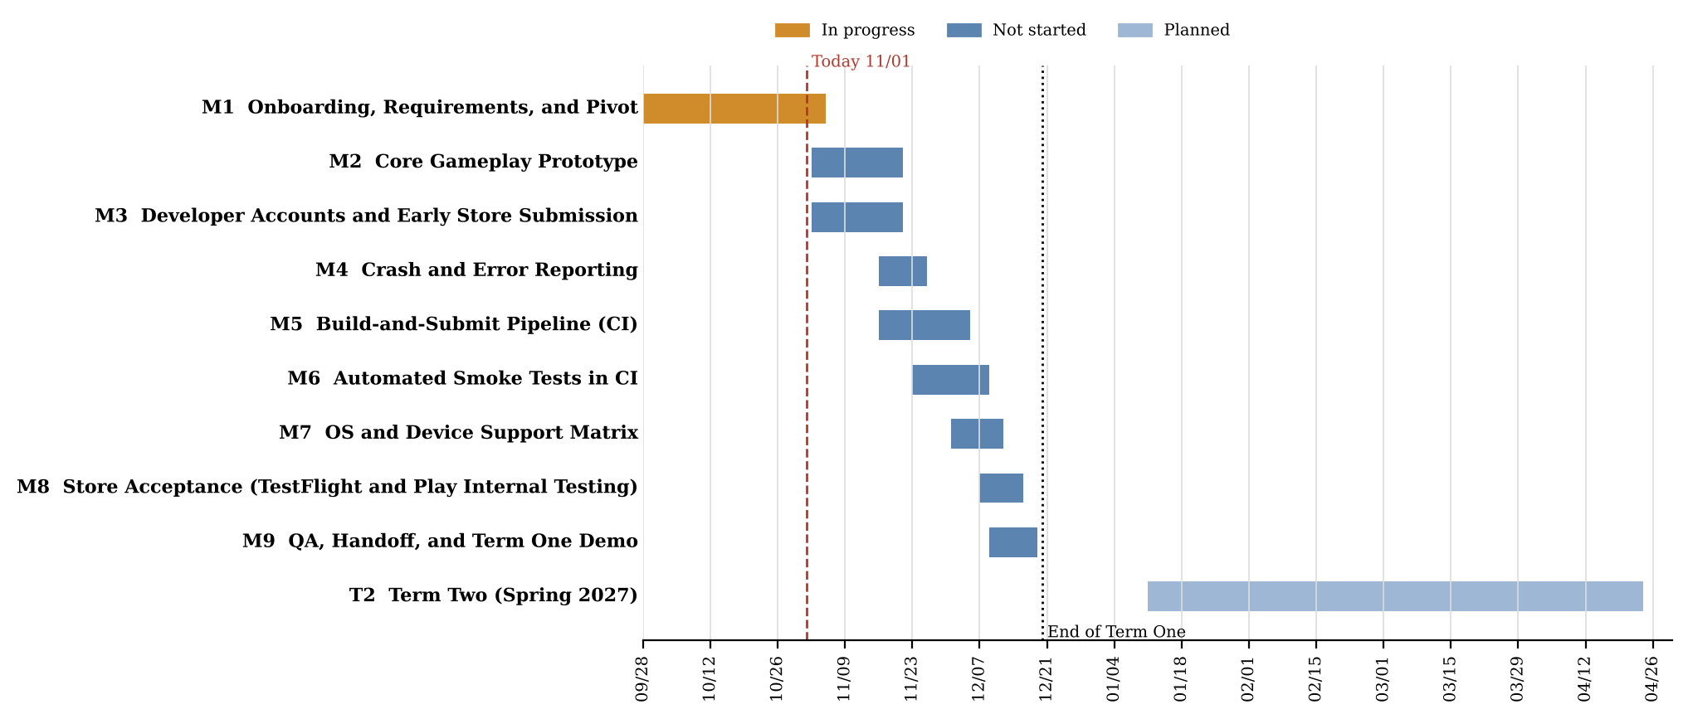
Note. Bars show milestone spans. The dashed line marks the portfolio date; the dotted line marks the end of Term One (12/20/2026). Full task-level charts are in Appendix A.

Table 7: Key Milestones and Responsible Parties
Milestone | Planned Finish | Responsible | Status
M1 Onboarding, requirements, and pivot to the Unity game | 11/04/2026 | All (lead: G. Veltri) | In progress
M2 Core gameplay prototype (one complete wave cycle) | 11/20/2026 | F. Hernandez Leon, G. Veltri, L. Hoyle | Not started
M3 Developer accounts and minimal build submitted to both stores | 11/20/2026 | A. Kelemen | Not started
M4 Crash and error reporting with triage runbook | 11/25/2026 | L. Hoyle | Not started
M5 Single-trigger signed build-and-submit pipeline | 12/04/2026 | A. Kelemen, L. Hoyle | Not started
M6 Automated smoke tests running in CI | 12/08/2026 | F. Hernandez Leon | Not started
M7 OS and device support matrix validated | 12/11/2026 | A. Kelemen | Not started
M8 TestFlight and Play internal testing acceptance | 12/15/2026 | A. Kelemen, G. Veltri | Not started
M9 QA, handoff, and Term One demonstration | 12/18/2026 | All | Not started
Term Two: gameplay expansion, offline leaderboard sync, accessibility | 03/16/2027 | All | Planned
Final 30-day crash-free window (99.5% target) | 04/16/2027 | All (lead: L. Hoyle) | Planned
Final presentation and live demonstration | 04/23/2027 | All | Planned

Risk Assessment
Table 8 lists the risks identified at this stage. Each risk is rated for likelihood and impact on a scale of 1 (low) to 3 (high); the product is the risk score, rated Low (1 to 2), Medium (3 to 4), or High (6 to 9). Ratings come from the team’s experience in Term One so far, the charter’s preliminary risk statement, and the published store review times. The risk register will be reviewed at each weekly meeting and updated in later versions of this portfolio. L is likelihood and I is impact. The Status column shows whether each risk is new since the pivot, carried over from the charter, or updated, and the realized risk that caused the pivot is listed last and closed.
Table 8: Risk Assessment and Mitigation Plan
Risk | L | I | Score / Rating | Status | Mitigation Plan
R1. Schedule compression from the late pivot | 3 | 3 | 9 / High | New | Defer non-essential gameplay to Term Two; run accounts, pipeline, and gameplay in parallel; track critical-path tasks weekly.
R2. Intellectual property: a Galaga-style game could copy protected assets, names, or sounds | 2 | 3 | 6 / High | New | Use only original or CC0 art and audio; choose an original title; review assets before each store submission.
R3. App store review delay or rejection, including account enrollment delays | 2 | 3 | 6 / High | Carried over | Enroll in week one; submit a minimal build by 11/20; follow store guidelines and data-safety forms; keep buffer before 12/15.
R4. Scope creep in game features | 3 | 2 | 6 / High | New | Freeze the Term One feature list (one wave cycle); route new ideas to a Term Two backlog approved by the team lead.
R5. Loss of the industry partner’s customer input | 3 | 2 | 6 / High | New | Keep Brett Jones and the IT representative engaged; recruit student playtesters; confirm direction with the instructor and mentor.
R6. iOS builds need macOS and Xcode; CI macOS minutes are limited | 2 | 2 | 4 / Medium | New | Use a team Mac when available; run iOS builds only on merges to main; cache the Unity Library folder.
R7. Unity license activation fails in CI | 2 | 2 | 4 / Medium | New | Follow GameCI activation steps early (task 5.1); store the license as an encrypted secret; keep a local manual build as fallback.
R8. Flaky Play Mode tests make CI unreliable | 2 | 2 | 4 / Medium | Carried over | Use fixed random seeds and deterministic wave data; test logic in Edit Mode where possible; track and fix flaky tests.
R9. Poor frame rate on the oldest supported devices | 2 | 2 | 4 / Medium | New | Pool projectiles and enemies; use sprite atlases; profile on the oldest device each sprint.
R10. Uneven Unity experience across the team | 2 | 2 | 4 / Medium | Carried over | Pair a game-development member with each other member; share short tutorials; review all pull requests.
R11. Too few sessions to measure the 99.5% crash-free rate | 2 | 2 | 4 / Medium | Carried over | Recruit testers early in Term Two and schedule play sessions throughout the final 30 days.
R12. Store fees and device gaps now fall on the team budget | 1 | 2 | 2 / Low | Updated | Budget $124 for store fees and a $300 contingency for a refurbished older device; use emulators and simulators for remaining gaps.
R13. Team availability during breaks and finals | 2 | 1 | 2 / Low | Carried over | Plan around the academic calendar; spread tasks so none depends on one person.
R14. Studio XE access not provided (charter risk) | — | — | Realized | Closed 10/30 | Resolved by moving to a team-owned Unity game; see Second Design Iteration.

The highest risk is schedule compression (R1). Access to the Studio XE code was the first task on the critical path, and four weeks passed without it, so both likelihood and impact are rated 3. Moving to an application the team controls removes the access dependency itself, but leaves fewer working days for the same release deliverables. The mitigation is to treat the release infrastructure, not game content, as the priority: a game with one complete wave cycle that is crash-monitored, tested in CI, signed, and accepted into both testing tracks meets every Term One requirement. Additional content is planned for Term Two.
Intellectual property (R2) is new with the pivot. Galaga’s gameplay style is widely imitated, but its name, characters, sprites, and sounds belong to Bandai Namco, and a store reviewer could reject a submission that appears to copy them. The impact is high because rejection would block requirement 6, and the likelihood is medium because the risk is fully preventable. The team will use only original or CC0 assets, keep an asset log with the license of each file, and choose an original title before the first store submission.
Store review and enrollment (R3) carried over from the charter. Apple’s Beta App Review and Google’s first review of a new developer account can each take days, and both are outside the team’s control (Apple Inc., n.d.-a; Google LLC, n.d.). The mitigation, already used in the original plan, is to submit a minimal build early, here by November 20, so that review times and policy issues are known before the release candidate is due. Scope creep (R4) and the loss of partner input (R5) are rated high-likelihood because the team now defines its own product; a frozen Term One feature list and regular feedback from the remaining stakeholders control both.
The medium risks are technical. iOS builds require Xcode on macOS (R6), and Unity must be activated with a license inside CI (R7); both are addressed by scheduling the pipeline tasks early and keeping a manual fallback. Flaky tests (R8) and frame rate on older devices (R9) are controlled by deterministic test data, object pooling, and regular profiling. Uneven Unity experience (R10) is managed by pairing, and the session count needed for the crash-free measurement (R11) is planned for early Term Two. The low risks, budget changes (R12) and team availability (R13), have small impacts and simple mitigations.
Design
The design has gone through two iterations. The initial design, presented at Design Review 1, was a release pipeline for the Studio XE application. The second iteration keeps the same pipeline structure and requirements but applies it to the team’s own Unity game. Because the project is software only, there is no mechanical or electrical design; those subsections from the template were removed, and the software design is divided into its subsystems.
Initial Design: Studio XE Release Pipeline
The initial concept (Figure 2) had four parts. Observability: the Sentry React Native SDK in development, preview, and production builds, with source maps uploaded from EAS and PII scrubbing enabled for healthcare, finance, and legal users. Release pipeline: EAS Build and EAS Submit profiles with signing secrets in GitHub, so one command produced signed iOS and Android builds. Quality gate: Maestro flows across all 19 screens, run by GitHub Actions on every pull request. Store acceptance and support matrix: an early minimal submission to TestFlight and Google Play internal testing, and a matrix of the current and two prior major OS versions validated on an iPhone 18 Pro and a Pixel 11 Pro provided by Studio XE.
Figure 2: Initial Design Concept for the Studio XE Release Pipeline (Design Review 1)
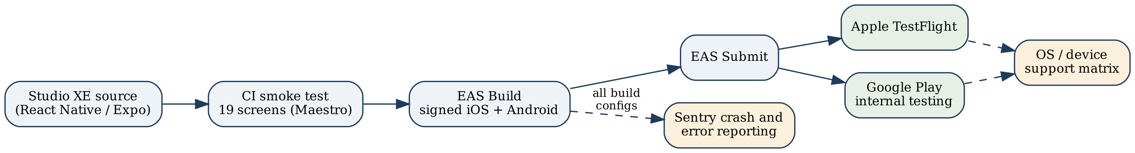

The design was sound but could not be built without the partner’s repository, Expo organization, and store accounts. By the end of October, none had been provided, and the Weekly Status Update of October 23 recorded that the team was preparing to build its own application. That decision led to the second iteration.
Second Design Iteration: Unity Arcade Shooter
The team chose a game because two members study game development, because an arcade shooter has a small and well-understood rule set that can be playable within three weeks, and because a game exercises every release requirement: it must be signed, store-approved, crash-monitored, tested, and run smoothly across many devices. Unity was chosen because one C# codebase builds for iOS, Android, and WebGL, which satisfies the cross-platform consistency requirement, and because its Test Framework supports automated Edit Mode and Play Mode tests that can run in CI (Unity Technologies, n.d.). On October 30, 2026, the team committed a Unity 6.3 project (editor 6000.3.24f1) to the team repository using the 2D Universal Render Pipeline (URP) template with the Input System 1.20 and Unity Test Framework 1.6 packages. The subsections below describe each subsystem.
Gameplay Design
The player’s ship moves left and right along the bottom of the screen and fires upward, with at most two shots on screen at a time so the player must aim rather than spray. Each wave begins with enemies flying in along curved spline paths and settling into a four-row formation that sways side to side. From the formation, individual enemies and small groups break away to dive at the player while firing, then loop back to their slots. Enemies in different rows are worth different points, and diving enemies are worth more than those in formation. The player starts with three lives and earns an extra life at fixed score thresholds. Clearing the formation starts the next wave, which is faster and dives more often. Figure 3 shows the screen layout used for the prototype.
Figure 3: Gameplay Screen Layout Concept (Portrait Phone)
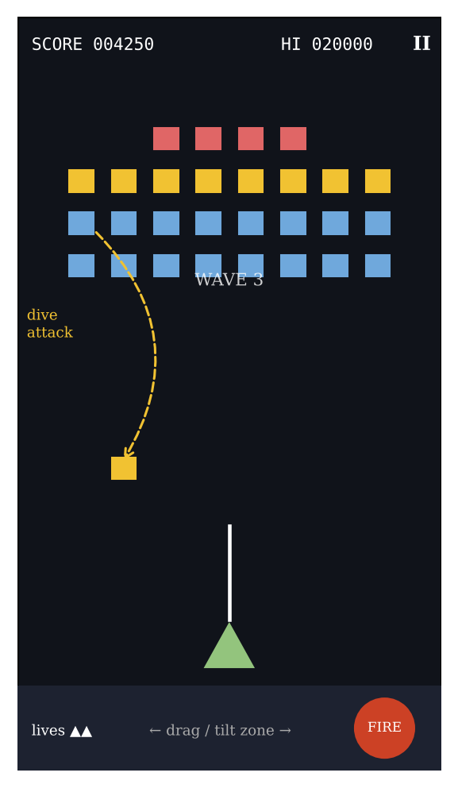
Note. Placeholder shapes stand in for original sprites. The bottom control zone keeps the player’s thumbs from covering the ship.

User Interface and Controls
The game uses portrait orientation on phones and a letterboxed portrait play field on the web. On touch screens, dragging anywhere in the lower control zone moves the ship and a large fire button sits at the lower right; a setting swaps it to the left for left-handed players. Keyboard (arrows and space) and gamepad controls are mapped through the Unity Input System so the same action map serves every platform. The heads-up display shows score, high score, lives, wave number, and a pause button sized for touch. Figure 4 shows the screen flow. Menus use high-contrast text, and the game pauses automatically when the app loses focus, in line with ISO 9241-110 and WCAG 2.2 (ISO, 2020; W3C, 2023).
Figure 4: Screen Flow
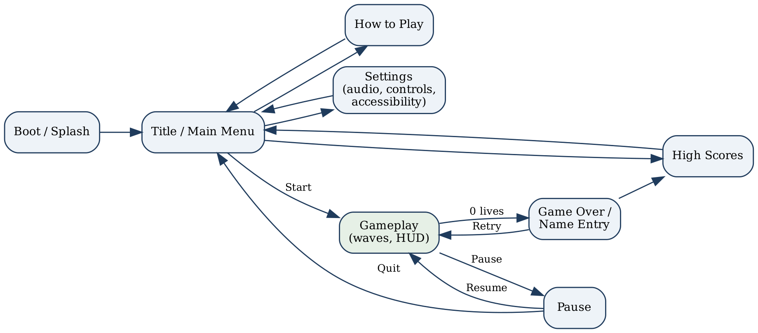

Software Architecture
Figure 5 shows the planned architecture. A small set of core services persists across scenes: a GameManager state machine (title, playing, paused, game over), an AudioManager, a SaveService for local high scores and settings, and a diagnostics wrapper around the Sentry Unity SDK that records breadcrumbs such as wave starts and scene loads. In the gameplay scene, wave definitions are stored as ScriptableObject assets so that new waves can be designed without code changes. The WaveManager reads these definitions and drives a FormationController, which spawns enemies and assigns them entry paths and dive attacks. Player and enemy projectiles come from an object pool to avoid garbage-collection pauses on older phones, and a ScoreManager raises events that update the HUD and tell the GameManager when the game is over. Keeping logic such as scoring and wave progression in plain C# classes allows it to be tested in fast Edit Mode tests.
Figure 5: Planned Software Architecture
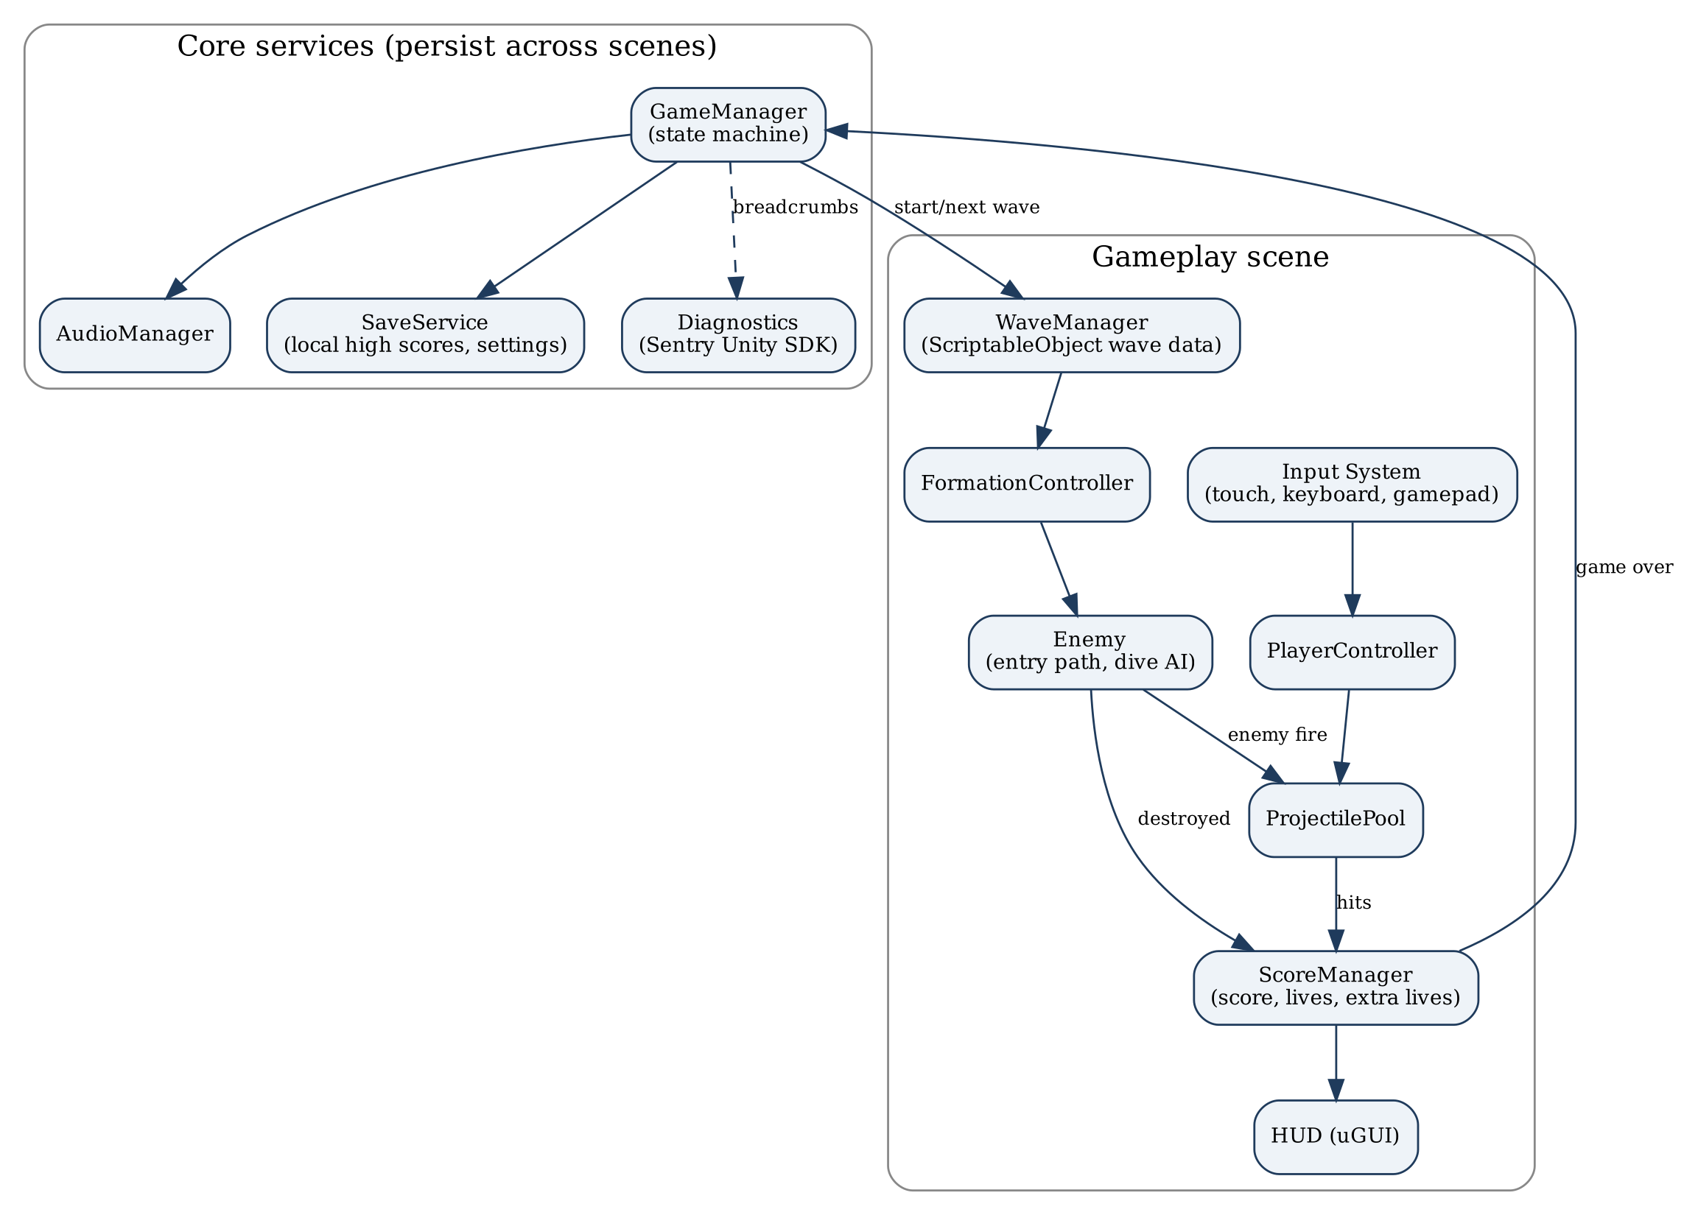

Figure 6 shows the GameManager state machine. Every state change is a single, testable transition, which lets the Play Mode smoke tests drive the game from Title to GameOver and assert the expected state at each step. The Paused state is entered automatically when the application loses focus, so a phone call or notification never costs the player a life.
Figure 6: GameManager State Machine
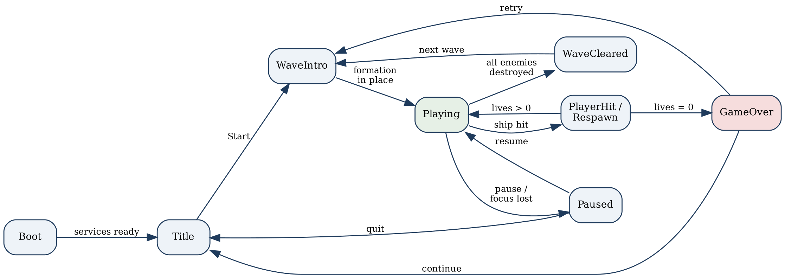

Release Pipeline and Observability Design
Figure 7 shows the revised pipeline. Every pull request triggers a GitHub Actions workflow that uses GameCI to run the Edit Mode and Play Mode tests; a failure blocks the merge (GameCI, n.d.). A merge to the main branch builds three targets. The Android build is signed with the upload key stored as an encrypted GitHub secret and uploaded to the Google Play internal testing track. The iOS build exports an Xcode project, which is signed and uploaded to TestFlight by fastlane on a macOS runner (fastlane, n.d.). The WebGL build is published to a web host for browser play. Build numbers are generated from the CI run so every binary can be traced to a commit, as NIST SP 800-218 recommends (Souppaya et al., 2022). The Sentry Unity SDK is initialized in both development and release builds with separate environments, debug symbols are uploaded during the build so native crashes are readable, and personal data collection is disabled (Sentry, n.d.), following the MASVS privacy controls (OWASP Foundation, n.d.). The triage runbook defines severity levels, who responds, and how a crash is reproduced, fixed, and verified.
Figure 7: Revised Build, Test, and Submit Pipeline
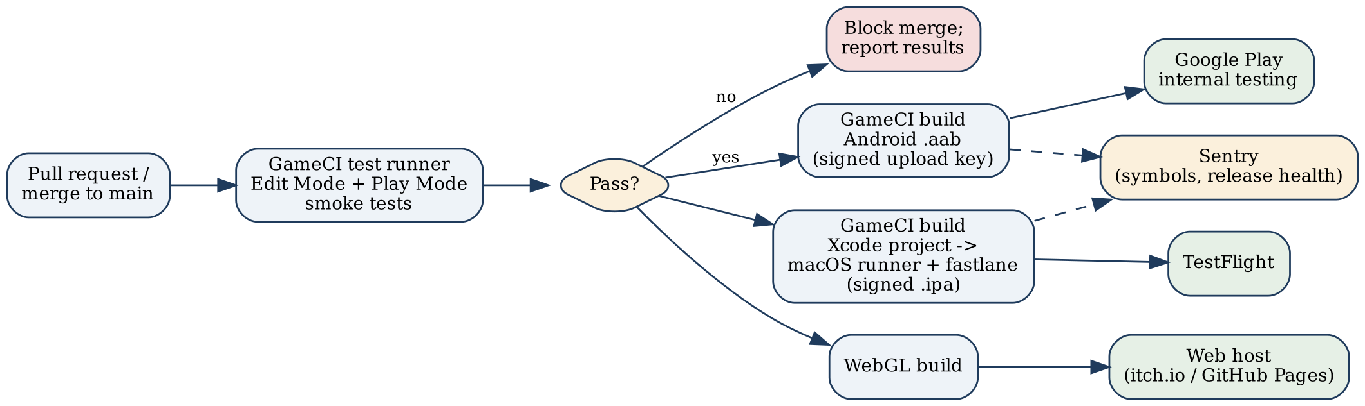

Test Design
Testing has three layers. Edit Mode unit tests cover pure logic: scoring, extra-life thresholds, wave progression, and save-file reading and writing. Play Mode smoke tests load every scene, navigate every menu screen, and run a scripted first wave with a fixed random seed, failing if any scene throws an error or the game does not reach the expected state. Manual device validation then runs the pipeline-built binaries on each entry in the support matrix and records frame rate, layout, and control results. Test plans and results are documented following ISO/IEC/IEEE 29119 (ISO, 2021), and the full Initial Testing Plan is due later in Term One.
Offline Play and Leaderboard Synchronization (Term Two)
The game is playable offline by design. In Term Two, scores earned offline will be queued locally with a timestamp and device identifier and uploaded when connectivity returns, while the high-score screen labels unsynchronized entries as pending. Conflicts follow simple documented rules: a player’s best score is kept, duplicate submissions of the same run are ignored, and the server timestamp decides ties. The leaderboard service will be selected at the start of Term Two; Unity Gaming Services Leaderboards is the leading candidate.
Traceability of Requirements to Design
Table 9 traces each functional requirement to the design elements that satisfy it and to the WBS tasks that build it. Every requirement is covered by at least one subsystem and one test, so a change to a requirement shows exactly which parts of the design and schedule it affects.
Table 9: Functional Requirements Traced to Design Elements
Requirement | Design Elements | Verified By | WBS
FR1 Interface and consistency | Screen flow (Fig. 4); shared Unity codebase; Input System action map; HUD layout (Fig. 3) | Five-user usability test; matrix layout check | 2.1, 2.4, 9.1
FR2 Core arcade loop | PlayerController, WaveManager, FormationController, Enemy, ProjectilePool, ScoreManager (Fig. 5); state machine (Fig. 6) | Playtest checklist; Unity Profiler | 2.1–2.4, 10.1
FR3 Crash and error reporting | Diagnostics service (Sentry Unity SDK); symbol upload; PII scrubbing; triage runbook (Fig. 7) | Test crashes per platform and configuration | 4.1–4.3
FR4 99.5% crash-free sessions | Sentry release health; breadcrumbs from GameManager | 30-day release-health export | 10.5
FR5 Automated smoke tests | Edit Mode and Play Mode suites; deterministic wave data; GameCI test runner (Fig. 7) | CI results on every pull request | 6.1–6.3
FR6 Signed pipeline and store acceptance | GameCI builds; fastlane; encrypted secrets; CI build numbers (Fig. 7) | Clean-checkout pipeline run; tester access in both tracks | 3.1–3.3, 5.1–5.3, 8.1–8.3
FR7 Support matrix and accessibility | Portrait layout; 44-point controls; contrast palette; WebGL build | Device, simulator, and browser validation | 7.1–7.3, 10.3
FR8 Offline play and leaderboard sync | SaveService; offline score queue; conflict rules | Airplane-mode test | 10.2

Final Design
The final design has not been reached. It will be documented in later revisions of this portfolio after the Final Design Concept Report and Design Review 2 in December 2026, and will include screenshots of the working build, test and device-validation results, and any changes driven by playtesting and store review.
Conclusion
At the time of this submission, the project is in the requirements and early prototyping stage. Onboarding and nondisclosure agreements were finished on October 2, 2026; the functional requirements, industry standards, stakeholder feedback, bill of materials, project timeline, and Design Review 1 were completed in October; and because the industry partner had not provided access to its application, the team moved the project to its own Unity arcade shooter on October 30, 2026, and committed the Unity 6.3 project to the team repository. This portfolio restates the objectives and functional requirements for the game, keeps every release-engineering deliverable from the original charter, rebuilds the timeline, and adds new risks, chiefly schedule compression and intellectual property.
The next steps are to confirm the new direction with the capstone instructor and faculty mentor, enroll in the Apple and Google developer programs, build the player controller and first enemy wave, and submit a minimal build to TestFlight and Google Play internal testing by November 20, 2026. Crash reporting, the CI pipeline, smoke tests, and device validation follow, leading to store acceptance by December 15 and the Term One demonstration on December 18, 2026.
References
Apple Inc. (n.d.-a). App Store review guidelines. Retrieved October 30, 2026, from https://developer.apple.com/app-store/review/guidelines/
Apple Inc. (n.d.-b). Human interface guidelines: Accessibility. Retrieved October 30, 2026, from https://developer.apple.com/design/human-interface-guidelines/accessibility
fastlane. (n.d.). fastlane documentation. Retrieved October 30, 2026, from https://docs.fastlane.tools/
GameCI. (n.d.). GameCI documentation: GitHub Actions. Retrieved October 30, 2026, from https://game.ci/docs/github/getting-started
Google LLC. (n.d.). Google Play Developer Program policies. Retrieved October 30, 2026, from https://play.google.com/about/developer-content-policy/
International Organization for Standardization. (2017). ISO/IEC/IEEE 12207:2017 Systems and software engineering—Software life cycle processes. https://www.iso.org/standard/63712.html
International Organization for Standardization. (2020). ISO 9241-110:2020 Ergonomics of human-system interaction—Part 110: Interaction principles. https://www.iso.org/standard/75258.html
International Organization for Standardization. (2021). ISO/IEC/IEEE 29119-2:2021 Software and systems engineering—Software testing—Part 2: Test processes. https://www.iso.org/standard/79428.html
International Organization for Standardization. (2022). ISO/IEC/IEEE 32675:2022 Information technology—DevOps—Building reliable and secure systems including application build, package and deployment. https://www.iso.org/standard/83670.html
International Organization for Standardization. (2023). ISO/IEC 25010:2023 Systems and software engineering—Systems and software quality requirements and evaluation (SQuaRE)—Product quality model. https://www.iso.org/standard/78176.html
Namco. (1981). Galaga [Arcade video game]. Namco.
OWASP Foundation. (n.d.). Mobile application security verification standard (MASVS). Retrieved October 30, 2026, from https://mas.owasp.org/MASVS/
Sentry. (n.d.). Unity SDK documentation. Retrieved October 30, 2026, from https://docs.sentry.io/platforms/unity/
Souppaya, M., Scarfone, K., & Dodson, D. (2022). Secure software development framework (SSDF) version 1.1 (NIST Special Publication 800-218). National Institute of Standards and Technology. https://doi.org/10.6028/NIST.SP.800-218
Unity Technologies. (n.d.). Unity Test Framework manual. Retrieved October 30, 2026, from https://docs.unity3d.com/Packages/com.unity.test-framework@1.6/manual/index.html
World Wide Web Consortium. (2023, October 5). Web content accessibility guidelines (WCAG) 2.2. https://www.w3.org/TR/WCAG22/
Appendix A
Project Timeline
Figures A1 and A2 show the complete revised Gantt charts. Task durations, predecessors, and owners are listed in the WBS in Appendix B. The original Studio XE Term One schedule, with labor hours and costs, is attached as the workbook CLC - Project Timeline and WBS.xlsx and will be updated to match this revision.
Figure A1: Term One Gantt Chart (Revised October 30, 2026)
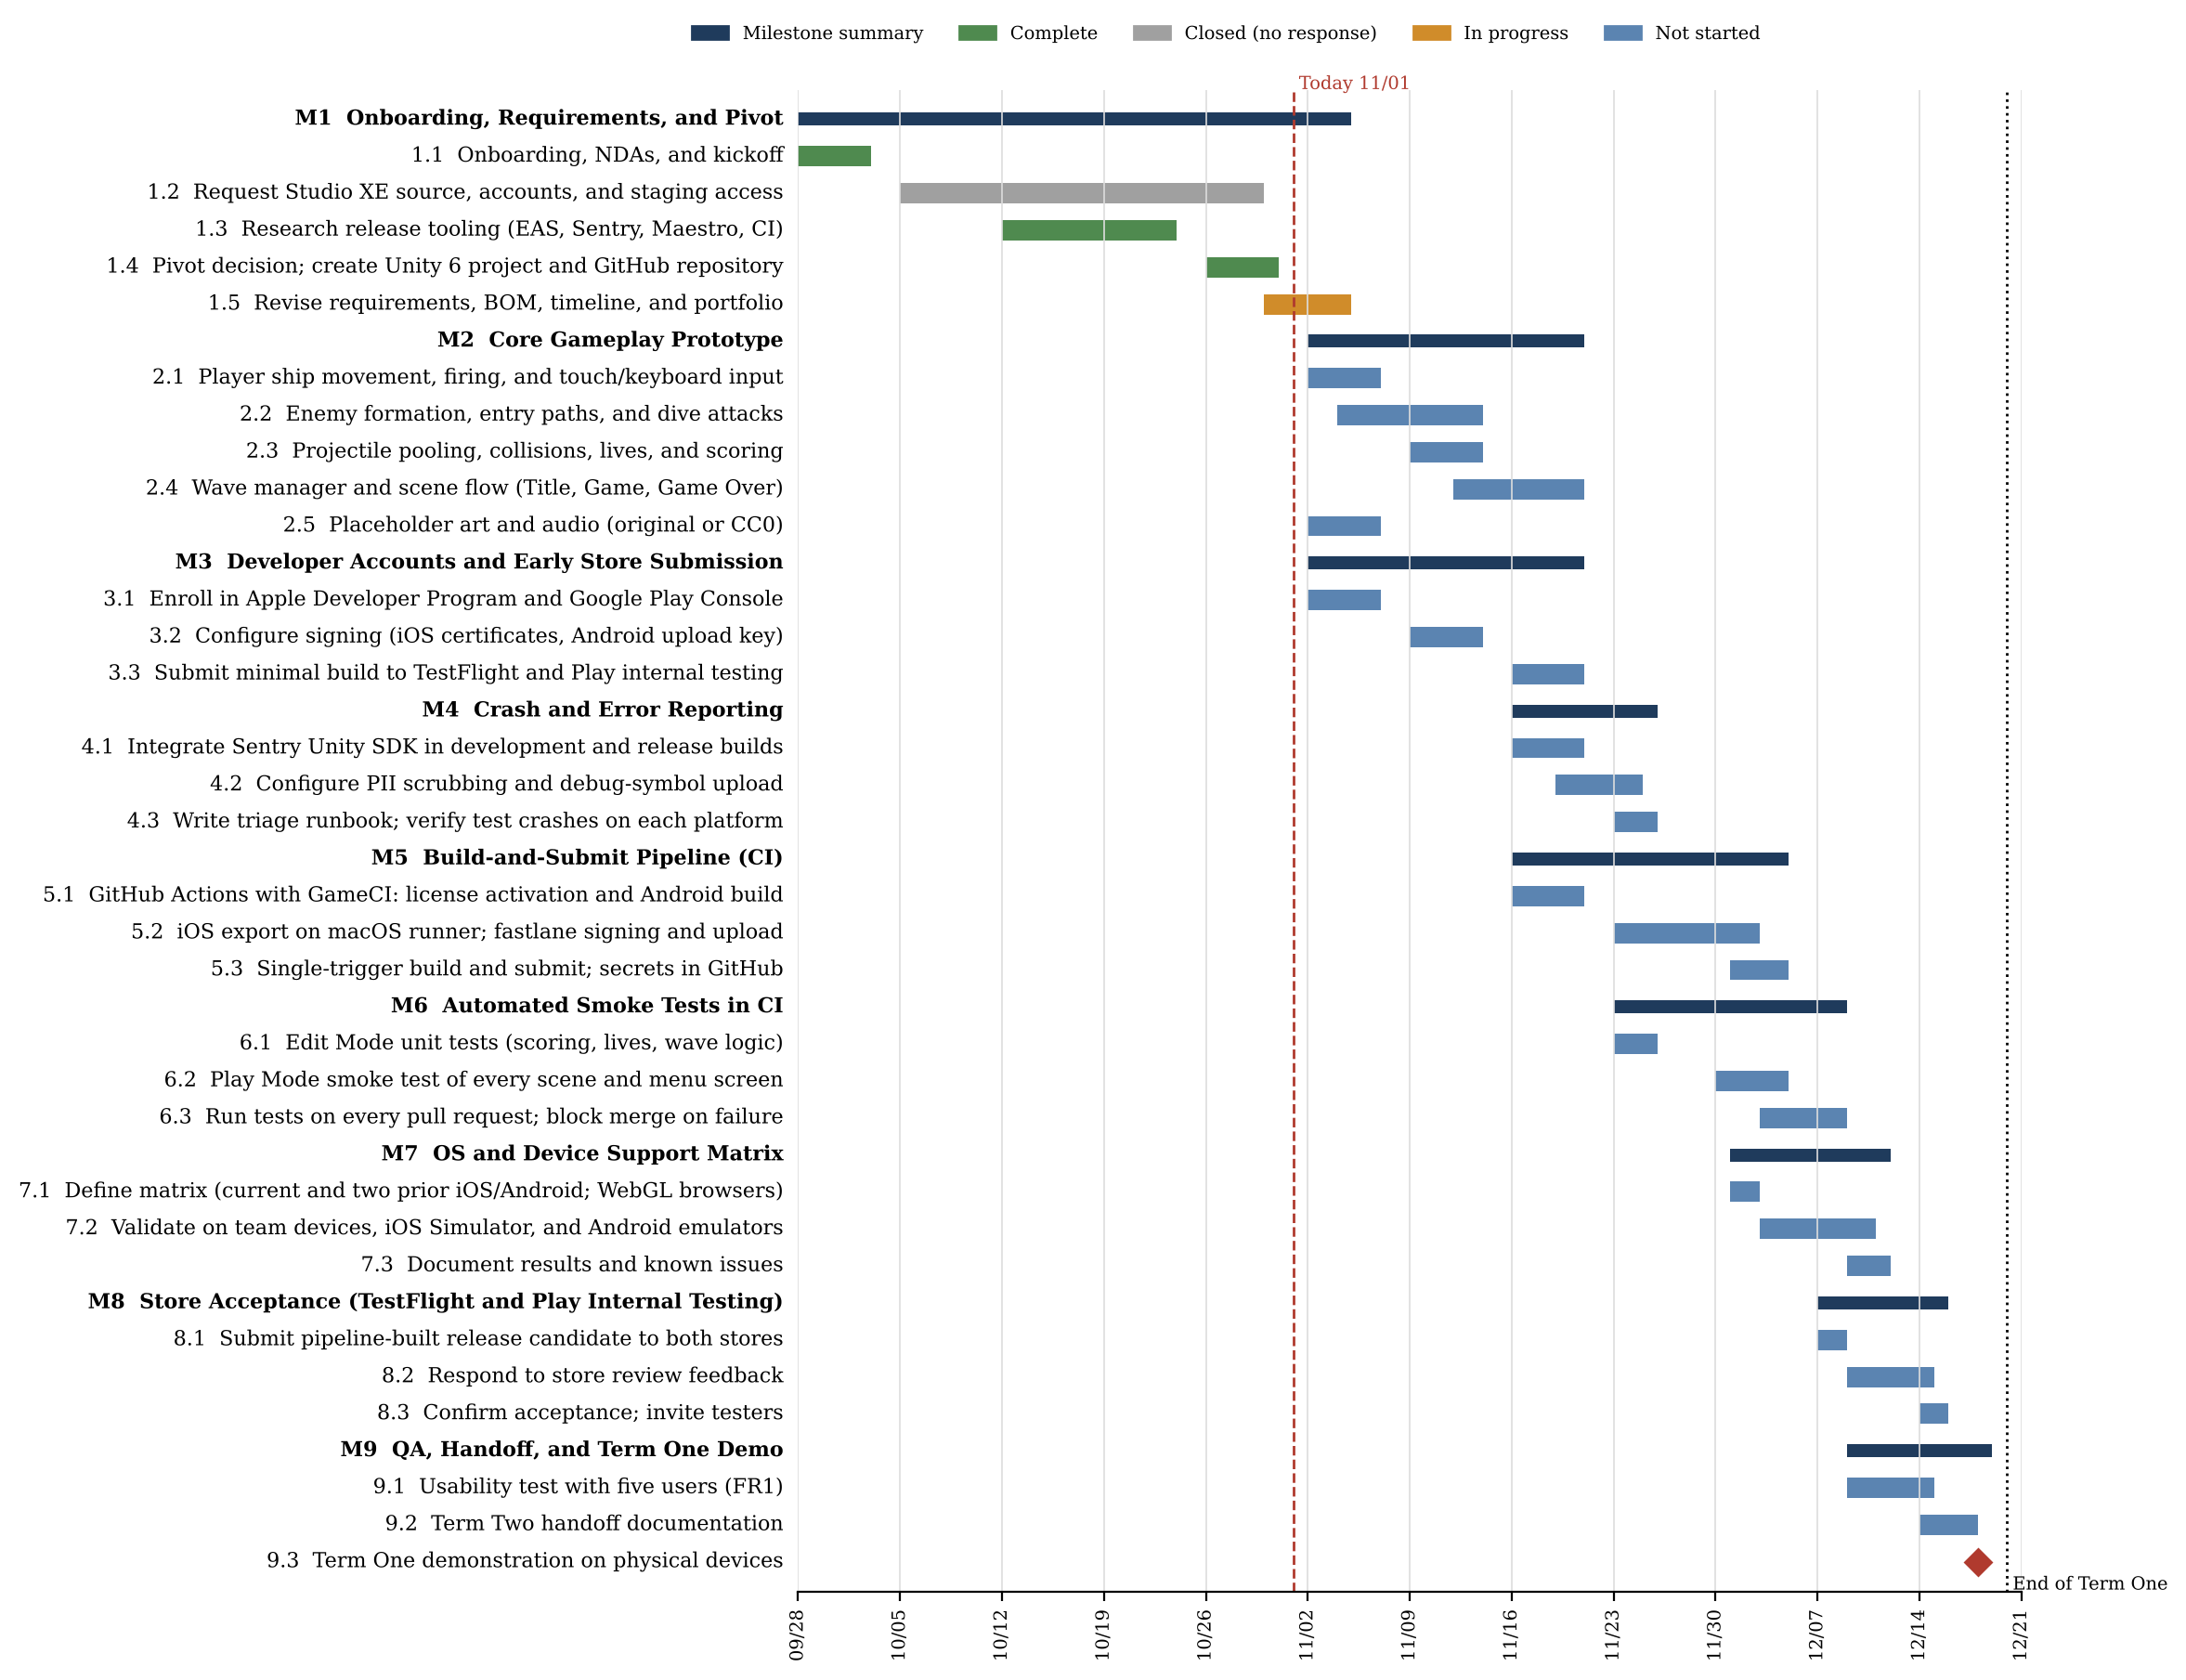
Note. Gray marks the closed Studio XE access request. The diamond marks the Term One demonstration.

Figure A2: Term Two Gantt Chart (Planned)
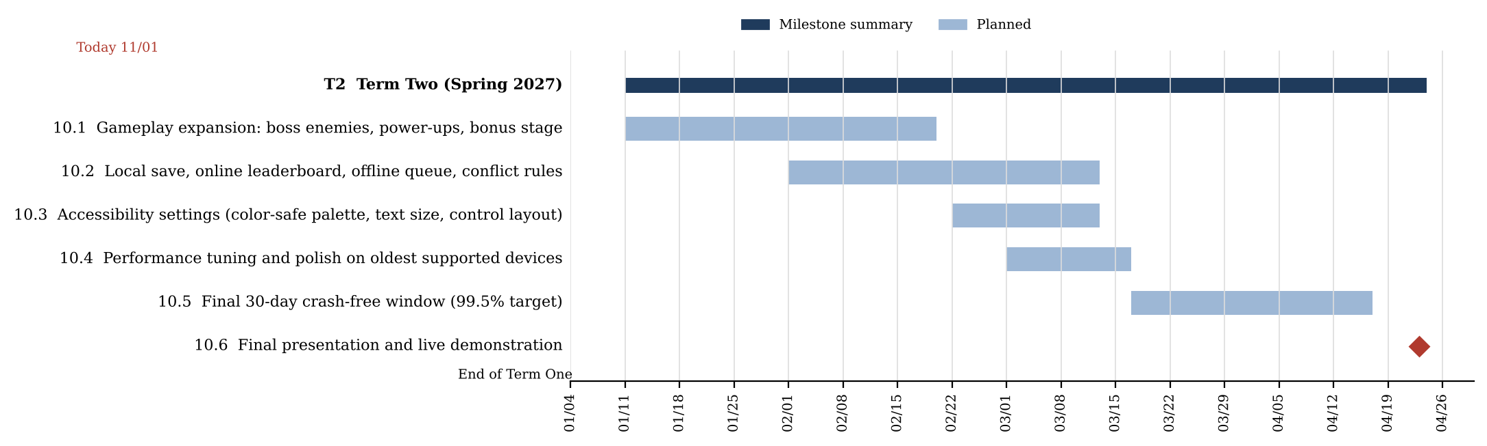

Appendix B
Work Breakdown Structure
Table B1 is the revised WBS. Durations are in working days (Monday to Friday, excluding Thanksgiving), and labor hours are days multiplied by assigned members and three hours per person per day. Course assignments such as weekly status updates, the Final Design Concept Report, Design Review 2, and the portfolio revision continue on the dates in the original workbook and are not repeated here.
Table B1: Work Breakdown Structure
ID | Milestone / Task | Owner | Days | Hours | Pred. | Start | Finish | Status
M1 | Onboarding, Requirements, and Pivot |  | 28 |  |  | 09/28/26 | 11/04/26 | In progress
1.1 | Onboarding, NDAs, and kickoff | All | 5 | 60 | None | 09/28/26 | 10/02/26 | Complete
1.2 | Request Studio XE source, accounts, and staging access | G. Veltri | 19 | 57 | 1.1 | 10/05/26 | 10/29/26 | Closed (no response)
1.3 | Research release tooling (EAS, Sentry, Maestro, CI) | All | 10 | 120 | 1.1 | 10/12/26 | 10/23/26 | Complete
1.4 | Pivot decision; create Unity 6 project and GitHub repository | All | 5 | 60 | 1.2, 1.3 | 10/26/26 | 10/30/26 | Complete
1.5 | Revise requirements, BOM, timeline, and portfolio | All | 4 | 48 | 1.4 | 10/30/26 | 11/04/26 | In progress
M2 | Core Gameplay Prototype |  | 15 |  |  | 11/02/26 | 11/20/26 | Not started
2.1 | Player ship movement, firing, and touch/keyboard input | F. Hernandez Leon | 5 | 15 | 1.4 | 11/02/26 | 11/06/26 | Not started
2.2 | Enemy formation, entry paths, and dive attacks | F. Hernandez Leon, G. Veltri | 8 | 48 | 2.1 | 11/04/26 | 11/13/26 | Not started
2.3 | Projectile pooling, collisions, lives, and scoring | L. Hoyle | 5 | 15 | 2.1 | 11/09/26 | 11/13/26 | Not started
2.4 | Wave manager and scene flow (Title, Game, Game Over) | G. Veltri | 7 | 21 | 2.2, 2.3 | 11/12/26 | 11/20/26 | Not started
2.5 | Placeholder art and audio (original or CC0) | A. Kelemen | 5 | 15 | 1.4 | 11/02/26 | 11/06/26 | Not started
M3 | Developer Accounts and Early Store Submission |  | 15 |  |  | 11/02/26 | 11/20/26 | Not started
3.1 | Enroll in Apple Developer Program and Google Play Console | A. Kelemen, G. Veltri | 5 | 30 | 1.4 | 11/02/26 | 11/06/26 | Not started
3.2 | Configure signing (iOS certificates, Android upload key) | A. Kelemen | 5 | 15 | 3.1 | 11/09/26 | 11/13/26 | Not started
3.3 | Submit minimal build to TestFlight and Play internal testing | A. Kelemen, L. Hoyle | 5 | 30 | 3.2, 2.1 | 11/16/26 | 11/20/26 | Not started
M4 | Crash and Error Reporting |  | 8 |  |  | 11/16/26 | 11/25/26 | Not started
4.1 | Integrate Sentry Unity SDK in development and release builds | L. Hoyle | 5 | 15 | 2.4 | 11/16/26 | 11/20/26 | Not started
4.2 | Configure PII scrubbing and debug-symbol upload | A. Kelemen | 4 | 12 | 4.1 | 11/19/26 | 11/24/26 | Not started
4.3 | Write triage runbook; verify test crashes on each platform | L. Hoyle | 3 | 9 | 4.2 | 11/23/26 | 11/25/26 | Not started
M5 | Build-and-Submit Pipeline (CI) |  | 13 |  |  | 11/16/26 | 12/04/26 | Not started
5.1 | GitHub Actions with GameCI: license activation and Android build | L. Hoyle | 5 | 15 | 1.4 | 11/16/26 | 11/20/26 | Not started
5.2 | iOS export on macOS runner; fastlane signing and upload | A. Kelemen, L. Hoyle | 6 | 36 | 5.1, 3.2 | 11/23/26 | 12/02/26 | Not started
5.3 | Single-trigger build and submit; secrets in GitHub | A. Kelemen | 4 | 12 | 5.2 | 12/01/26 | 12/04/26 | Not started
M6 | Automated Smoke Tests in CI |  | 10 |  |  | 11/23/26 | 12/08/26 | Not started
6.1 | Edit Mode unit tests (scoring, lives, wave logic) | F. Hernandez Leon | 3 | 9 | 2.4 | 11/23/26 | 11/25/26 | Not started
6.2 | Play Mode smoke test of every scene and menu screen | F. Hernandez Leon, G. Veltri | 5 | 30 | 6.1 | 11/30/26 | 12/04/26 | Not started
6.3 | Run tests on every pull request; block merge on failure | L. Hoyle | 4 | 12 | 6.2, 5.1 | 12/03/26 | 12/08/26 | Not started
M7 | OS and Device Support Matrix |  | 9 |  |  | 12/01/26 | 12/11/26 | Not started
7.1 | Define matrix (current and two prior iOS/Android; WebGL browsers) | A. Kelemen | 2 | 6 | 3.3 | 12/01/26 | 12/02/26 | Not started
7.2 | Validate on team devices, iOS Simulator, and Android emulators | All | 6 | 72 | 7.1, 5.3 | 12/03/26 | 12/10/26 | Not started
7.3 | Document results and known issues | A. Kelemen | 3 | 9 | 7.2 | 12/09/26 | 12/11/26 | Not started
M8 | Store Acceptance (TestFlight and Play Internal Testing) |  | 7 |  |  | 12/07/26 | 12/15/26 | Not started
8.1 | Submit pipeline-built release candidate to both stores | A. Kelemen | 2 | 6 | 5.3, 4.3, 6.3 | 12/07/26 | 12/08/26 | Not started
8.2 | Respond to store review feedback | A. Kelemen, L. Hoyle | 4 | 24 | 8.1 | 12/09/26 | 12/14/26 | Not started
8.3 | Confirm acceptance; invite testers | G. Veltri | 2 | 6 | 8.2 | 12/14/26 | 12/15/26 | Not started
M9 | QA, Handoff, and Term One Demo |  | 8 |  |  | 12/09/26 | 12/18/26 | Not started
9.1 | Usability test with five users (FR1) | F. Hernandez Leon | 4 | 12 | 7.2 | 12/09/26 | 12/14/26 | Not started
9.2 | Term Two handoff documentation | G. Veltri | 4 | 12 | 8.3, 9.1 | 12/14/26 | 12/17/26 | Not started
9.3 | Term One demonstration on physical devices | All | 1 | 12 | 9.2 | 12/18/26 | 12/18/26 | Not started
T2 | Term Two (Spring 2027) |  | 75 |  |  | 01/11/27 | 04/23/27 | Planned
10.1 | Gameplay expansion: boss enemies, power-ups, bonus stage | F. Hernandez Leon, G. Veltri | 30 | 180 | 9.3 | 01/11/27 | 02/19/27 | Planned
10.2 | Local save, online leaderboard, offline queue, conflict rules | L. Hoyle | 30 | 90 | 9.3 | 02/01/27 | 03/12/27 | Planned
10.3 | Accessibility settings (color-safe palette, text size, control layout) | A. Kelemen | 15 | 45 | 10.1 | 02/22/27 | 03/12/27 | Planned
10.4 | Performance tuning and polish on oldest supported devices | All | 12 | 144 | 10.1 | 03/01/27 | 03/16/27 | Planned
10.5 | Final 30-day crash-free window (99.5% target) | All | 23 | 276 | 10.4 | 03/17/27 | 04/16/27 | Planned
10.6 | Final presentation and live demonstration | All | 1 | 12 | 10.5 | 04/23/27 | 04/23/27 | Planned
 | Total labor hours (Term One / Term Two) |  |  | 843 / 747

Appendix C
Bill of Materials
Table C1 is the proposed revision of the team BOM for the Unity game. The original BOM (rev 1.0, 10/13/2026) is attached as CLC - Bill of Materials (BOM).xlsx. The main changes are that the Apple and Google developer fees move from Studio XE to the team budget, the Studio XE services and the two partner-funded phones are removed, and the Expo, Maestro, and React Native tools are replaced with Unity, GameCI, and fastlane. Claude Pro was approved and issued to all four members in October 2026, as budgeted. Free-tier services are listed at $0; prices should be confirmed before purchase.
Table C1: Bill of Materials (Proposed Revision 2.0)
ID | Item | Purpose / Deliverable | Qty | Unit Cost | Total | Funding | Lead Time
1 | Claude Pro (individual plan, $20 + 9.1% tax) | All deliverables: code review, tests, documentation | 28 lic-mo | $21.82 | $610.96 | Team budget | Approved; accounts issued Oct 2026
2 | Apple Developer Program | FR6: iOS signing, TestFlight | 1 yr | $99.00 | $99.00 | Team budget | 1–2 days (individual)
3 | Google Play Console registration | FR6: Android signing, internal testing | 1 | $25.00 | $25.00 | Team budget | 1–7 days (verification)
4 | Unity 6.3 (Personal) | FR1, FR2: game engine and builds | 4 seats | $0.00 | $0.00 | Free | Immediate
5 | Unity Test Framework, Input System, 2D URP | FR1, FR5: controls, rendering, tests | — | $0.00 | $0.00 | Free | Immediate
6 | GitHub repository and Actions (GameCI) | FR5, FR6: CI tests and builds | 1 org | $0.00 | $0.00 | Free tier | Immediate
7 | fastlane | FR6: iOS signing and TestFlight upload | — | $0.00 | $0.00 | Open source | Immediate
8 | Sentry (free tier) and Unity SDK | FR3, FR4: crash reporting, release health | 1 org | $0.00 | $0.00 | Free tier | Immediate
9 | Xcode, Android Studio, VS Code / Rider | FR7: simulators, emulators, editing | 4 | $0.00 | $0.00 | Free | Immediate
10 | Team-owned iPhones and Android phones | FR7: device validation; live demo | 4+ | $0.00 | $0.00 | Team-owned | On hand
11 | Original or CC0 art and audio | FR2: game assets without IP risk | — | $0.00 | $0.00 | Free | Immediate
12 | Contingency: refurbished older test phone | FR7: fill support-matrix gaps if needed | 1 | $300.00 | $300.00 | Team budget | 3–5 days
 | Total projected team cost |  |  |  | $1,034.96
 | Team budget remaining (of $4,000) |  |  |  | $2,965.04

Appendix D
Customer Feedback
Table D1 reproduces the stakeholder feedback collected on October 10, 2026, and signed by all four team members on October 11, 2026. The feedback was collected for the Studio XE application; the mapping of each item to the game’s functional requirements is shown in the last column.
Table D1: Stakeholder Feedback and Resulting Design Requirements
Stakeholder | Conversation Notes | Design Requirements | Maps To
David Lutz  Company contact, Studio XE (Community HDP)  10/10/2026 | Discussed the overall goals of the project and expectations for the application’s final functionality. Reviewed the importance of an application that is reliable, easy to use, and consistent across devices. Discussed development challenges including troubleshooting, testing, and a smooth user experience. Identified the importance of tracking progress, addressing problems as they arise, and preparing a final demonstration. | 1. Crash and error reporting across all build configurations, with a triage runbook.  2. Automated build-and-submit pipeline producing signed iOS and Android builds.  3. Acceptance into Apple TestFlight and Google Play internal testing.  4. Automated smoke test of all screens in CI.  5. Documented, device-validated OS support matrix.  6. Shared component definition for web and mobile (5+ components).  7. Offline cache with staleness indicators; optimistic writes with documented conflict handling.  8. Crash-free session rate of 99.5% or better across the final 30 days.  9. Final presentation and live demonstration on physical devices. | 1: FR3  2: FR6  3: FR6  4: FR5  5: FR7  6: FR1  7: FR8  8: FR4  9: FR6, M9
Brett Jones  Potential customer  10/10/2026 | Discussed the intended audience and making the application useful to it. Reviewed prioritizing important features and managing development time. Considered usability and a consistent experience across platforms. Discussed reviewing the finished product and gathering feedback for improvement. | Clean, intuitive interface with easy navigation between screens.  Consistent design across web, iOS, and Android.  Clear feedback for interactions, errors, and connectivity issues.  Responsive, accessible layout with readable text and appropriately sized controls. | FR1, FR2  FR1  FR8  FR7
IT Representative  Company IT worker  10/10/2026 | Discussed keeping the application stable and minimizing unexpected crashes. Identified the need for effective error reporting for troubleshooting. Considered compatibility across devices and operating systems. Highlighted documentation for future updates and maintenance. | Implement crash and error reporting.  Ensure compatibility across supported operating systems and devices.  Provide clear troubleshooting and maintenance documentation. | FR3, FR4  FR7  FR3, FR6

Summary from the original form: the stakeholders’ requirements focus on a reliable, user-friendly product that works consistently across web, iOS, and Android, supported by automated testing, crash and error reporting, documented OS compatibility, and graceful behavior when connectivity is limited.

